

**The Most Important Crypto-Commerce Tool To Help Humans Cooperate is Crypto peer-to-peer.**

Peer-to-peer refers to the exchange or sharing of information, data, or assets between parties without the involvement of a central authority. Peer-to-peer (P2P) involves decentralized interactions among individuals and groups.

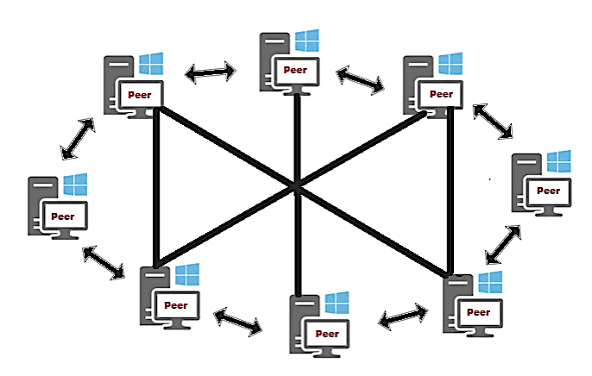

This approach is been used to to avoid centralized data ownership. Centralized data ownership is easily used for censorship and manipulation by government , data totalitarian allows them to use and misuse personal data , it is also a threat to businesses continuity since it has the capability to turn off the entire software ecosystem . This threat is reaching a national sovereignty level, as nations become dependent upon large foreign corporations for their software operation.

Why peer-to-peer is unique

There are so may outstanding properties of crypto peer-to-peer.

1 . users directly to each other without third party or intermediary .

2. allows to keep sensitive data under user control because it is decentralized.

3. You do not the permission of a third party to connect to the network

4. It is trustless.